The Path of Vision: Convolutional Image Transformation
1. Objective
The objective of this experiment is to demonstrate the fundamental operations of a Convolutional Neural Network (CNN) by applying convolution, activation, and pooling on a grayscale image using TensorFlow. An edge detection kernel is used to extract important features from the image, and the intermediate outputs are visualized.

2. Python source code
- Python
- TensorFlow – for tensor operations and convolution
- NumPy – for numerical processing
- Matplotlib – for visualization

# import the necessary libraries
import numpy as np
import tensorflow as tf
import matplotlib.pyplot as plt

# set the param
plt.rc('figure', autolayout=True)
plt.rc('image', cmap='magma')

# define the kernel (edge detection)
kernel = tf.constant([[-1, -1, -1],
[-1, 8, -1],
[-1, -1, -1]], dtype=tf.float32)

# load the image
image = tf.io.read_file('Ganesha.jpg')
image = tf.io.decode_jpeg(image, channels=1)
image = tf.image.resize(image, size=[300, 300])

# plot the image
img = tf.squeeze(image).numpy()
plt.figure(figsize=(5, 5))
plt.imshow(img, cmap='gray')
plt.axis('off')
plt.title('Original Gray Scale image')
plt.show()

# Reformat
image = tf.image.convert_image_dtype(image, dtype=tf.float32)
image = tf.expand_dims(image, axis=0) # shape: [1, H, W, 1]

# reshape kernel: [filter_height, filter_width, in_channels, out_channels]
kernel = tf.reshape(kernel, [3, 3, 1, 1])

# convolution layer
conv_fn = tf.nn.conv2d
image_filter = conv_fn(
input=image,
filters=kernel,
strides=[1, 1, 1, 1], # must be 4D
padding='SAME',
)

plt.figure(figsize=(15, 5))

# Plot the convolved image
plt.subplot(1, 3, 1)
plt.imshow(tf.squeeze(image_filter).numpy(), cmap='gray')
plt.axis('off')
plt.title('Convolution')

# activation layer
relu_fn = tf.nn.relu
image_detect = relu_fn(image_filter)

plt.subplot(1, 3, 2)
plt.imshow(tf.squeeze(image_detect).numpy(), cmap='gray')
plt.axis('off')
plt.title('Activation')

# pooling layer (using tf.nn.pool)
image_condense = tf.nn.pool(
input=image_detect,
window_shape=(2, 2),
pooling_type='MAX',
strides=(2, 2),
padding='SAME',
)

plt.subplot(1, 3, 3)
plt.imshow(tf.squeeze(image_condense).numpy(), cmap='gray')
plt.axis('off')
plt.title('Pooling')

plt.show()

3. Sample Output
When you run the code above, you will see output as shown below
A. Evaluation
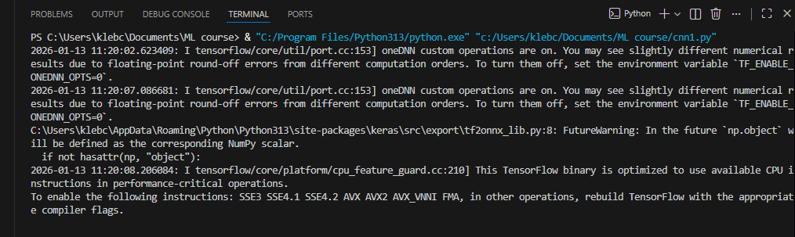

B. Visualization
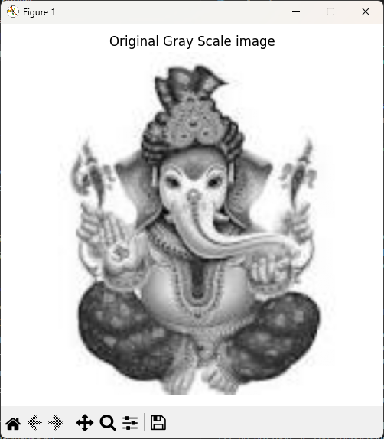
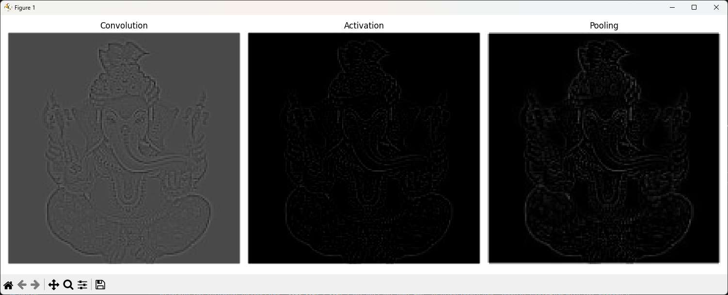

4. Methodology
4.1 Image Preprocessing
- The input image (Ganesha.jpg) is read from disk using TensorFlow I/O functions.
- The image is converted to grayscale and resized to 300 × 300 pixels.
- Pixel values are normalized to the range [0, 1].
- The image tensor is reshaped to match the required input format for convolution:
- [batch_size, height, width, channels]
- = [1, 300, 300, 1]

4.2 Convolution Operation
- A 3 × 3 Laplacian edge detection kernel is defined:
This kernel enhances regions with sharp intensity changes, making it effective for edge detection.
- The convolution operation is performed using tf.nn.conv2d with:
  - Stride = 1
  - Padding = SAME
- The output of this layer highlights edges and fine details in the image.

4.3 Activation Function
- The ReLU (Rectified Linear Unit) activation function is applied to the convolution output.
- ReLU removes negative pixel values and retains positive responses, introducing non-linearity.
- This step helps emphasize strong edge features while suppressing weak responses.

4.4 Pooling Operation
- Max Pooling is applied using a 2 × 2 window with stride 2.
- Pooling reduces the spatial dimensions of the feature map while preserving important features.
- This step improves computational efficiency and provides spatial invariance.

5. Results and Observations
Original Image
- A grayscale image resized to 300 × 300 pixels.
- Serves as the input for further processing.
Convolution Output
- Clearly highlights edges and contours in the image.
- Contains both positive and negative values due to kernel response.
Activation Output (ReLU)
- Negative values are suppressed.
- Edges become more prominent and visually clear.
Pooling Output
- The image size is reduced.
- Major edge features are retained while minor details are removed.

6. Conclusion
This experiment successfully demonstrates the working principles of a Convolutional Neural Network using TensorFlow. By applying convolution, activation, and pooling operations, important features such as edges are extracted from the image. The results show how CNN layers progressively transform raw image data into meaningful feature representations. This approach forms the foundation for advanced tasks such as image classification and object detection.

7. Applications
- Edge detection
- Feature extraction
- Image classification
- Computer vision and deep learning models

